— WORLD POLITICS IN THE 1930s —

September 14, 1930
The Nazi party becomes the second largest political party in Germany.

September 19, 1931
Britain leaves the gold standard, leading many in the U.S. to believe another stock market disaster is imminent. Over the next two months, hundreds of banks will close as Americans hastily close out their accounts.

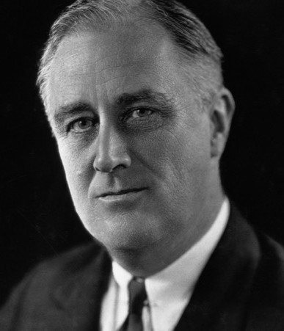
September, 1931
Franklin Delano Roosevelt
Japan invades Manchuria, violating the Kellogg-Briand pact, setting it on the path to World War II.

March 4, 1933
Franklin Roosevelt’s first inauguration as President of the United States. In his first 100 days in office, Roosevelt launches the New Deal, including dozens of federal programs to help agriculture. FDR calls for social security, a fair tax system, and a host of federal jobs programs to get people back to work.

January 30, 1933
Adolf Hitler becomes Chancellor of Germany, a critical turning point for Germany and for the world. Hitler proposes eliminating traditional party politics, creating a unified one-
party state and eradicating all opposition to the Nazi party.

March 3, 1933
President Franklin D. Roosevelt gives his first radio "fireside chat," directly connecting to the American public. Radio allows Roosevelt to calmly explain his methods for social change, and gives a boost to his public standing. The radio also allows him to reach the American people while concealing his polio symptoms.

August 14, 1935
FDR signs the Social Security Act into law, establishing retirement insurance, a federal-state program of unemployment compensation, and federal grants for state welfare programs.

November 15, 1935
The Nazis revoke German citizenship for all Jews. With the 1936 Olympic games scheduled in Berlin, the German government tones down public anti-Jewish rhetoric over worries that international criticism of Hitler's government could lead organizers to transfer the games to another country.

January 20, 1937
Roosevelt is inaugurated for the second time as a result of one of the greatest landslide victories in American history. As Americans tune in to their radios from all over the country, FDR focuses his inaugural address on the poor "forgotten" American.

June 25, 1938
FDR signs the Fair Labor Standards Act, creating a 44-hour workweek. Later, the act moved to a 40- hour week. Minimum wages start at 25 cents an hour and increase to 40 cents per hour within six years.

November 9-10, 1938
Nazis in Germany torched synagogues, vandalized Jewish homes, schools, and businesses, and killed close to 100 Jews. In the aftermath of Kristallnacht, also called the “Night of Broken Glass,” some 30,000 Jewish men were arrested and sent to Nazi concentration camps.

September 1, 1939
The German army, air force, and navy launch a concerted attack on Poland, utilizing Blitzkrieg tactics to annihilate the Polish army. Within four weeks, the Germans destroyed most of the Polish army and occupied the western and central regions of Poland.

September 3, 1939
British and French governments declare war against Germany.

November 4, 1939
U.S. passes Neutrality Act of 1939. In the end, the terms of the Neutrality Acts became irrelevant once the United States joined the Allies in the fight against Nazi Germany and Japan in December 1941.

October, 1929

— AMERICAN LIFE IN THE 1930s —

The Stock Market crashes, and fortunes of investors around the world are destroyed. President Herbert Hoover, an Iowa native, is President of the United States. Many eventually blame him for the plight of Americans. Unemployed and homeless people live in shantytowns they name “Hoovervilles.”

February 26, 1931
In response to resentment of "foreign" workers amidst rising unemployment, a team of armed Immigration and Naturalization Service agents seal off the small public park of La Placita, a popular gathering spot for Mexican-Americans in Los Angeles. The 400 men and women gathered there are taken into custody, kicking off a tidal wave of Mexican-Americans deportations. Between 300,000 and 500,000 Mexican-Americans are forced out of the United States in the 1930s.

May 11-13, 1934
A dust storm ravages several Midwestern and Western states including Texas, Oklahoma, Arkansas, Kansas, and Colorado, forcing hundreds of families to leave their farms. These storms will plague the nation for the next nine years, causing devastating agricultural damage to America's prairie lands and leaving thousands homeless.

January 18, 1937
Record rainfall overflows the banks of the Ohio River, leaving 1 million Americans homeless, and $250 million in property damage. Radio stations around the nation broadcast news about the flood for weeks without commercial breaks. Most broadcasts are filled with messages for rescue crews, as many government agencies have no other means of communication.

May 1937
Another dust storm hits the West and Midwest. Economic recovery comes to a halt, sending the economy of the region into a second depression and local morale to a new low.

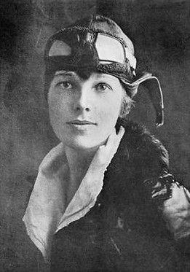
May 27, 1937
Amelia Earhart
Construction finishes on San Francisco’s Golden Gate Bridge.

July 2, 1937
Amelia Earhart crashes off the coast of Howland Island in the Pacific Ocean in her attempt to become the first woman to fly around the world. The news media round-the-clock coverage of the event fascinates the American public.

April 20, 1939
New York City holds the World’s Fair, drawing on the theme "The World of Tomorrow." The fair includes the first exhibition of television, ushering in a new era of media and entertainment. The theme is meant to provide an escape from the realities of the Great Depression and looming World War.

— ARTS & SCIENCE IN THE 1930s —

January 13, 1930
The first Mickey Mouse comic strip is published in the New York Mirror.

February 18, 1930
Arizona scientists reveal their newest discovery -- a ninth planet they name Pluto, after the Greek God of the underworld. The discovery sparks public interest in space and inspires Walt Disney to introduce a new animated character, Pluto -- Mickey Mouse's canine companion.

April 1, 1930
For the first time, the 30th U.S. Census asks whether the respondents owned a radio, reflecting an increased interest in communication technology and consumer goods.

October 5, 1930
CBS broadcasts the New York Philharmonic live over the radio for the first time. Since the historic broadcast, the Philharmonic has continued to be a consistent presence on national radio.

March 3, 1931
Congress and President Hoover approve The Star Spangled Banner by Francis Scott Key as the U.S. national anthem.

April 25, 1935
The first around-the-world telephone conversation spans from New York to San Francisco, Indonesia, Holland, England and back to New York. The call marks a new era in technological advancement.

April 16, 1936
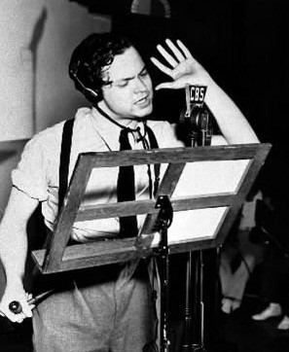
As part of the job stimulus program of the Works Project Administration, Orson Welles directs an all- black cast of Macbeth for the Negro People's Theatre. Both the
Orson Welles broadcasting “War of the Worlds”.
New York Times and the New York Daily News praise the production.

December 21, 1937
Disney releases Snow White and the Seven Dwarfs. The film is the first full-length animated feature (83 minutes in length) in color and with sound.

October 30, 1938
Orson Welles airs his famous “War of the Worlds” broadcast on CBS radio, shocking the nation with his realistic-sounding broadcast of a fictional alien invasion in Grovers Mill, New Jersey. By 1938, nearly 80% of American households own a radio.

— CIVIL RIGHTS IN THE 1930s —

January 1932
Hattie Carraway becomes first woman elected to the U.S. Senate (Arkansas).

March 4, 1933
FDR appoints Frances Perkins as Secretary of Labor, making her the first woman to hold a cabinet position.

June 18, 1934
The Indian Reorganization Act, also called Wheeler–Howard Act, is enacted by Congress, and decreases federal control of Native American affairs, allowing tribes to write constitutions and recognizing rights to self-government.

June 1936
Mary McLeod Bethune is named Director of Negro Affairs in the National Youth Administration. She is the first black woman to receive a major federal appointment

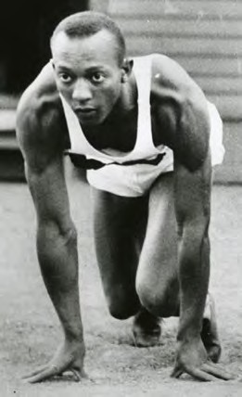
August 3-9, 1936
Jesse Owens
African American athlete Jesse Owens wins four gold medals at the Berlin Olympics in front of Adolf Hitler, who has recently begun his campaign for the "dominance" of the Aryan race. News of Owens' accomplishment sparks public interest; however, Owens continues to face racial inequality at home.

September 1937
Chinese Workers' Mutual Aid Association is founded in San Francisco to help workers of all trades get organized, including those from restaurants, laundries, farms, canneries, and docks.

December 1938
Luisa Moreno spearheads El Congreso de Pueblos de Hablan Española (the Spanish-Speaking People's Congress) in California, aiming to improve
labor conditions and civil rights for Latinos living in the United States. This marks first national effort to bring together Latino workers from different ethnic backgrounds: Cubans and Spaniards from Florida, Puerto Ricans from New York, Mexicans and Mexican Americans from the Southwest.

SOURCES:
Library of Congress http://www.loc.gov/teachers/ classroommaterials/presentationsandactivities/presentations/ timeline/depwwii/art/

The American History Online www.theamericanhistory.org

PBS
http://www.pbs.org/wgbh/americanexperience/features/timeline/ worlds/
Wessel’s Living History http://www.livinghistoryfarm.org/

American Studies at the University of Virginia http://xroads.virginia.edu/

January 1932

Further Exploration Through the Arts
The Tender Land showcases American farm life in the midst of the Great Depression, and touches on themes of family, coming of age, growth and change, fear and suspicion of outsiders, and the cycle of life. Below you will find suggestions for other works which explore similar ideas and settings, as well as a listing of other works by Aaron Copland.

— LITERATURE —
The Grapes of Wrath by John Steinbeck (1939)
Steinbeck’s Pulitzer Prize-winning epic of the Great Depression chronicles the Dust Bowl migration of the 1930s and tells the story of one Oklahoma farm family, the Joads, driven from their homestead and forced to travel west to the promised land of California. This is a drama that is intensely human yet majestic in its scale and moral vision, elemental yet plainspoken, tragic but ultimately stirring in its human dignity.

Of Mice and Men by John Steinbeck (1937)
The compelling story of two outsiders striving to find their place in an unforgiving world. Drifters in search of work, George and his simple-minded friend Lennie have nothing in the world except each other and a dream--a dream that one day they will have some land of their own. Eventually they find work on a ranch in California’s Salinas Valley, but their hopes are doomed as Lennie, struggling against extreme cruelty, misunderstanding, and feelings of jealousy, becomes a victim of his own strength.

Let Us Now Praise Famous Men by James Agee and Walker Evans (1941)
The basis for the opera The Tender Land, this book is a record of place and of the people who shaped the land, and stands as one of the most influential books of the twentieth century.

What to Listen For in Music by Aaron Copland (1939)
In this fascinating analysis of how to listen to music intelligently, Aaron Copland raises two basic questions: Are you hearing everything that is going on? Are you really being sensitive to it? Aaron Copland's provocative suggestions for listening to music from his point of view will bring you a deeper appreciation of the most rewarding of all art forms.
SOURCE: www.goodreads.com

Our Town by Thornton Wilder (1938)

— THEATRE —

Winner of the 1938 Pulitzer Prize for Drama, Our Town tells the story of the fictional American small town of Grover's Corners between 1901 and 1913 through the everyday lives of its citizens. A 1940 movie adaption (starring William Holden as George Gibbs) had an original score composed by Aaron Copland.

Oklahoma! by Richard Rodgers and Oscar Hammerstein II (1931)
Based on Lynn Riggs' 1931 play, Green Grow the Lilacs, Oklahoma! tells the story of cowboy Curly McLain and his romance with farm girl Laurey Williams, and is the first musical written by the team of composer Richard Rodgers and librettist Oscar Hammerstein II. The musical is considered one of the most influential works in the American musical theatre, owing to its full integration of song, character, plot, and dance. The original production was choreographed by Agnes de Mille, who collaborated with Aaron Copland on Rodeo in 1942.

Waiting For Lefty by Clifford Odets (1935)
This 1935 play consists of a series of related vignettes concerning a group of cab drivers who are planning a labor strike. It was staged by the Group Theatre, a New York theatre company focused on producing new plays, particularly those that mirrored the social and political climate of the day. Playwright Clifford Odets and Aaron Copland were good friends, and both were called to testify in Senator Joseph McCarthy's anticommunist hearings.

Annie by Charles Strouse and Martin Charnin (1977)
A Broadway musical set during the Great Depression and based on the popular Harold Gray comic strip Little Orphan Annie. This popular family musical has had three Broadway productions, two movies, and a television adaptation. The stage version draws heavily from its Great Depression setting, and includes the songs “We’d Like to Thank You, Herbert Hoover” and “A New Deal For Christmas.”

Rodeo (1942)

— DANCE —

Dancer and choreographer Agnes de Mille felt that the traditional Russian style of ballet was stale and out of touch, especially with American audiences. In her view, dance needed to speak to people here and now. With that in mind, she choreographed Rodeo as the first ballet to feature American tap dancing and indigenous folk dance, along with classical ballet technique. The music for Rodeo was written by Aaron Copland, and the piece premiered in 1942.

Appalachian Spring (1944)
One of choreographer Martha Graham’s most celebrated works, Appalachian Spring explores the lives of a young pioneer husband and his bride beginning a life together on the American frontier. The music was composed by Aaron Copland, who had been commissioned by Graham and Elizabeth Sprague Coolidge to write a ballet with "an American theme.” Copland won the 1945 Pulitzer Prize for Music for Appalachian Spring.

SOURCE: http://artsedge.kennedy-center.org/

— MUSIC —

More by Aaron Copland:
El Salón México (1936)
Copland said, “I was attracted by the spirit of the place and by the Mexican people. Using Mexican melodies seemed appropriate. My purpose was not merely to quote literally, but to heighten without in any way falsifying the natural simplicity of Mexican tunes.” Much to Copland's surprise and delight, El Salón México was welcomed warmly in Mexico and has consistently been one of his most performed pieces.

Billy the Kid Ballet Suite (1938)
Lincoln Kirstein and Eugene Loring of Ballet Caravan asked Copland to compose music for a cowboy ballet. According to Copland, “Lincoln tempted me with several books of western tunes, and Loring wrote a scenario about the notorious bandit of the Southwest, Billy the Kid. I became intrigued with using tunes such as ‘Git Along Little Dogies, ‘The Old Chisholm Trail’, and ‘Goodbye Old Paint’." The ballet is still performed regularly, and the orchestral suite of six connecting movements is one of Copland's most popular works.

Fanfare for the Common Man (1942)
Fanfare for the Common Man was written in response to a solicitation from Eugene Goosens, conductor of the Cincinnati Symphony Orchestra, for a musical tribute honoring those engaged in World War II. Copland later wrote, "The challenge was to compose a traditional fanfare, direct and powerful, yet with a contemporary sound." To the ultimate delight of audiences, Copland managed to weave musical complexity with popular style.

Lincoln Portrait (1942)
One of Copland's most popular pieces, Lincoln Portrait was commissioned during the early years of World War II for a program of three new works by American composers. Copland chose excerpts from Lincoln's own words for the narration. The piece has been performed on many significant occasions and with innumerable narrators, among them Carl Sandburg, William Warfield, Eleanor Roosevelt, and Copland himself.

Copland’s Contemporaries:

George Gershwin
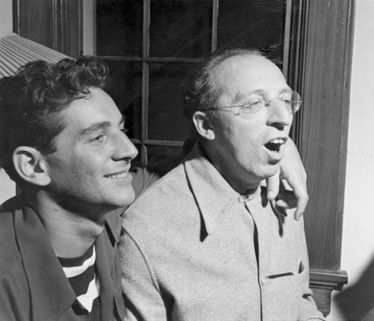
George Gershwin was one of the most significant American composers of the 20th century, known for popular stage and screen numbers as well as jazz and classical compositions. His most ambitious work, Porgy and Bess, is considered to be among the most important American musical compositions of the 20th century. In writing what he called his “folk opera”, Gershwin drew from both popular and classical influences. Many of his works are now standards, including “Someone to Watch Over Me”, “Summertime”, and what is perhaps his best-known work, “Rhapsody in Blue.”

Leonard Bernstein
Bernstein was one of the first American-born conductors to receive worldwide fame. Flamboyant, inspired, and voracious in his conducting style, Bernstein got his big break conducting the New York Philharmonic in 1943. He composed the scores for the musical West Side Story and the operetta Candide.

Music of the 1930s:
Leonard Bernstein and Aaron Copland

Benny Goodman
Also known as "The King of Swing", Benny Goodman was a clarinetist, composer, and band leader from the 1920s and 1930s. At the height of his popularity in the 1930's, his was the first jazz band to play Carnegie Hall. In 1947, Goodman commissioned Aaron Copland to compose a clarinet concerto, which would premiere on an NBC radio broadcast on November 6, 1950.

Woody Guthrie
Many of Guthrie’s early songs are based on his experiences in the Dust Bowl era during the Great Depression, which earned him the nickname "The Dust Bowl Troubadour". His most famous songs include “This Land is Your Land” and “Talking Dust Bowl Blues.”

Marian Anderson
Deemed one of the finest contraltos of her time, Marian Anderson's voice made her famous on both sides of the Atlantic. In 1939 she was invited by President Roosevelt to perform at the White House. However, Constitution Hall, where Anderson was scheduled to perform, was open only to white performers. Eleanor Roosevelt instead invited Anderson to perform on the steps of the Lincoln Memorial on Easter Sunday. In front of a crowd of more than 75,000, Anderson offered up a riveting performance that was broadcast live for millions of radio listeners.

Billie Holiday
Billie Holiday is considered one of the best jazz vocalists of all time. Discovered at the age of 18 in a Harlem jazz club, Holiday went on to record with Benny Goodman, Teddy Wilson, Duke Ellington,

Count Basie, Artie Show, and Lester Young, who gave Holiday her nickname "Lady Day". In 1939, Holiday debuted two of her most famous songs "God Bless the Child" and "Strange Fruit."

Alan Lomax and the 1938 Library of Congress Folk-Song Expedition
Acting as “Assistant in Charge” for the Library of Congress, Lomax toured Michigan in 1938, recording the music of people across the state. A selection of Lomax’s recordings have been compiled under the name “Michigan-I-O”, and is available for download or purchase on CD. The full scope of recordings available can be found at the Library of Congress online at https:// www.loc.gov/collections/alan-lomax-in-michigan/

SOURCES:
Library of Congress: http://memory.loc.gov/diglib/ihas/loc.natlib.ihas.200000006/default.html

Boosey & Hawkes: The Classical Music Specialists http://www.boosey.com/cr/composer/Aaron+Copland

Conscience vs. McCarthy: The Political Aaron Copland by Bill Morelock http://news.minnesota.publicradio.org/features/2005/05/03_morelockb_unamerican/

— VISUAL ARTS —

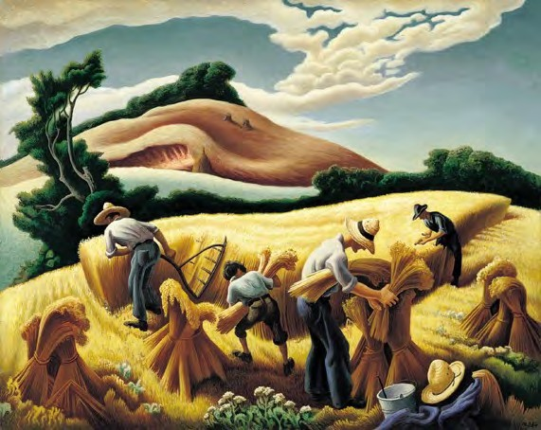
American Regionalism
“Cradling Wheat” by Thomas Hart Benton (1938)
Regionalism, or American Scene painting, is an American realist modern art movement that was popular from the 1920s through the 1950s in the United States. The artistic focus was from artists who shunned city life and rapidly developing technological advances to create scenes of rural life. Regionalist style was at its height from 1930 to 1935, and is be s t k now n t hr o ug h t he s o - ca l le d "Regionalist Triumvirate" of Grant Wood in Iowa, Thomas Hart Benton in Missouri, and John Steuart Curry in Kansas. During the Great Depression of the 1930s, Regionalist art was widely appreciated for its reassuring
images of the American heartland. Probably the most famous piece from the American Regionalism movement is Grant Wood’s “American Gothic”. Other well-known paintings include Wood’s “Daughters of the American Revolution”, Thomas Hart Benton’s “Cradling Wheat” and “Achelous and Hercules”, and John Steuart Curry’s “Baptism in Kansas” and “Tornado Over Kansas”.

Art from the Works Progress Administration
On May 6, 1935, the Works Progress Administration was created to help provide economic relief to the citizens of the United States who were suffering through the Great Depression. Certain visionary U.S. politicians decided to combine the creativity of the new art movements with the values of the American people. The Federal Art Project (FAP) created over 5,000 jobs for artists and produced over 225,000 works of art for the American people. Many of these works of art have been lost or destroyed, but some works can be found on display at the Smithsonian Museum and the Illinois State Museum. A great number can also be viewed digitally via The Library of Congress website.

— FILM —

Movies from the 1930s
The Wizard of Oz
Snow White and the Seven Dwarves Modern Times
Mr. Smith Goes to Washington
Paper Moon
The Purple Rose of Cairo Bonnie and Clyde
The Cradle Will Rock

O Brother, Where Art Thou?

