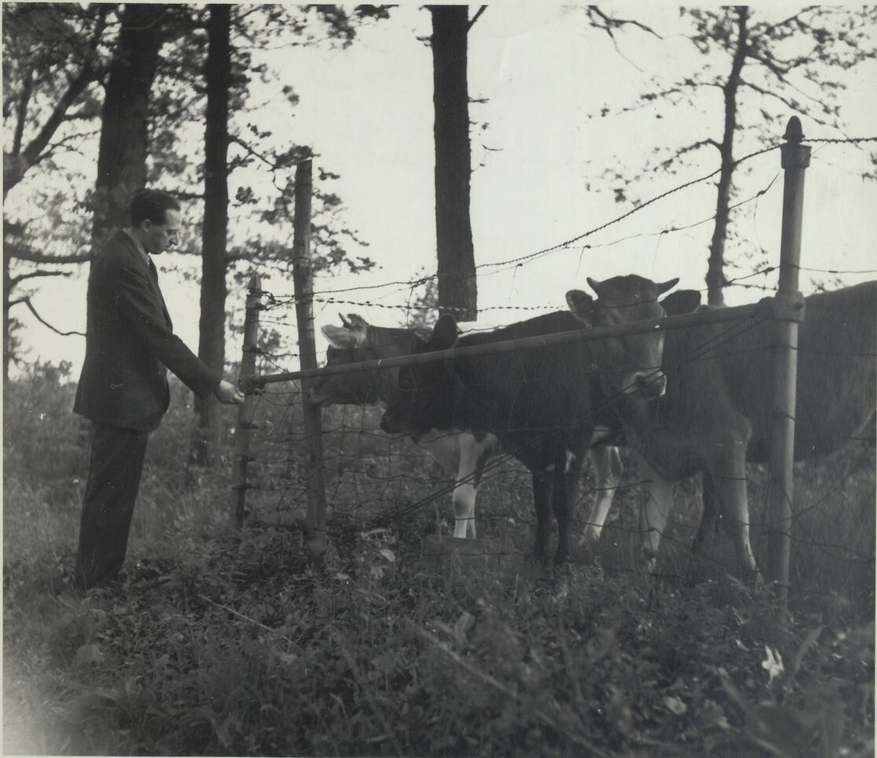
The composer Aaron Copland feeding cows

The American composer and conductor Aaron Copland (1900-1990) wrote extensively for the theater, the concert hall, and for cinema. In Copland’s ballets, orchestral works, film scores, piano pieces, songs, choral works, and chamber music, we hear a wide spectrum of musical styles, with influences including not only jazz and American folk music, but also newer compositional techniques pioneered by European composers such as Igor Stravinsky and Arnold Schoenberg. Copland’s early studies with Nadia Boulanger in Paris had a profound impact on his approach to composition, and Boulanger’s mentorship of Copland along with many other of his contemporaries was reflected later in Copland’s life as he mentored and taught many important American musicians, most especially Leonard Bernstein. Copland was called “the dean of American composers” by the writer and composer Virgil Thomson. Among Copland’s most famous compositions are “Appalachian Spring,” “Fanfare for the Common Man,” and “Rodeo.”

By the time Copland composed the opera “The Tender Land” between 1952 and 1954, he had already become well-known for several works that became associated with an “American” sound, and he had recently won an Oscar for “Best Score” for “The Heiress” (1950). In “The Tender Land” we hear Copland’s broad lyricism, his humor, his sense for drama, and his optimism. The version we are presenting at UA is a chamber arrangement made by Murry Sidlin, with the same group of thirteen instruments that Copland used in his original version of “Appalachian Spring.”

Michael Dauphinais, DMA
Vocal Coach
University of Arizona Opera Theater
Fred Fox School of Music

More by Aaron Copland:
El Salón México (1936)
Copland said, “I was attracted by the spirit of the place and by the Mexican people. Using Mexican melodies seemed appropriate. My purpose was not merely to quote literally, but to heighten without in any way falsifying the natural simplicity of Mexican tunes.” Much to Copland's surprise and delight, El Salón México was welcomed warmly in Mexico and has consistently been one of his most performed pieces.

Billy the Kid Ballet Suite (1938)
Lincoln Kirstein and Eugene Loring of Ballet Caravan asked Copland to compose music for a cowboy ballet. According to Copland, “Lincoln tempted me with several books of western tunes, and Loring wrote a scenario about the notorious bandit of the Southwest, Billy the Kid. I became intrigued with using tunes such as ‘Git Along Little Dogies, ‘The Old Chisholm Trail’, and ‘Goodbye Old Paint’." The ballet is still performed regularly, and the orchestral suite of six connecting movements is one of Copland's most popular works.

Fanfare for the Common Man (1942)
Fanfare for the Common Man was written in response to a solicitation from Eugene Goosens, conductor of the Cincinnati Symphony Orchestra, for a musical tribute honoring those engaged in World War II. Copland later wrote, "The challenge was to compose a traditional fanfare, direct and powerful, yet with a contemporary sound." To the ultimate delight of audiences, Copland managed to weave musical complexity with popular style.

Lincoln Portrait (1942)
One of Copland's most popular pieces, Lincoln Portrait was commissioned during the early years of World War II for a program of three new works by American composers. Copland chose excerpts from Lincoln's own words for the narration. The piece has been performed on many significant occasions and with innumerable narrators, among them Carl Sandburg, William Warfield, Eleanor Roosevelt, and Copland himself.

Copland’s Contemporaries:

George Gershwin
George Gershwin was one of the most significant American composers of the 20th century, known for popular stage and screen numbers as well as jazz and classical compositions. His most ambitious work, Porgy and Bess, is considered to be among the most important American musical compositions of the 20th century. In writing what he called his “folk opera”, Gershwin drew from both popular and classical influences. Many of his works are now standards, including “Someone to Watch Over Me”, “Summertime”, and what is perhaps his best-known work, “Rhapsody in Blue.”

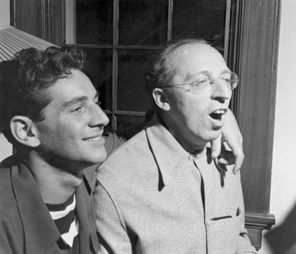
Leonard Bernstein
Bernstein was one of the first American-born conductors to receive worldwide fame. Flamboyant, inspired, and voracious in his conducting style, Bernstein got his big break conducting the New York Philharmonic in 1943. He composed the scores for the musical West Side Story and the operetta Candide.

Thanks to Intermountain Opera Bozeman for the use of these study guide materials

