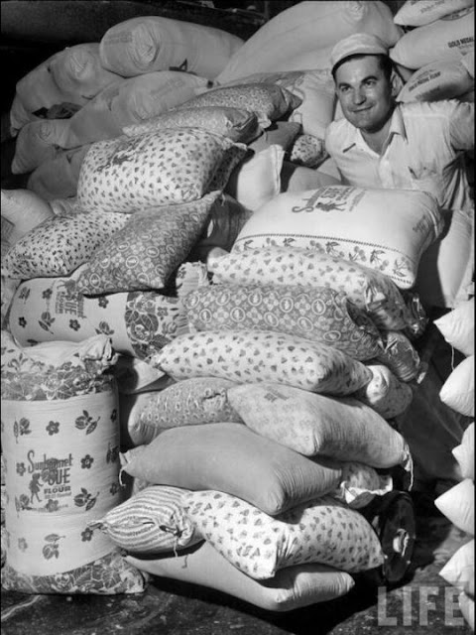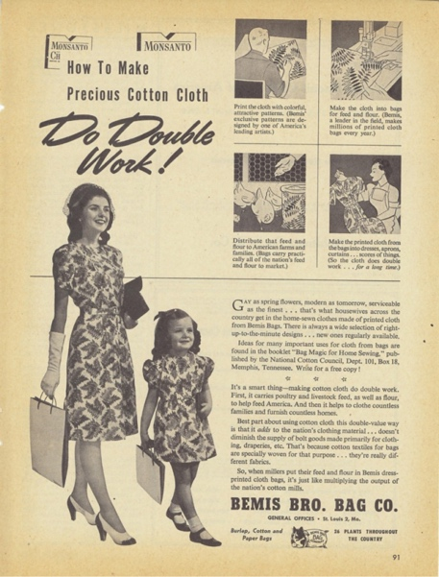

Costume Design for The Tender Land
University of Arizona

The rural Midwest of the 1930’s was not a particularly glamorous time, but in the American spirit of Can Do, fashion does have an interesting history.

"Women in poor rural areas of the United States made clothing from cotton commodity textile bags out of necessity. The practice was especially prevalent during the extreme hardships of the Great Depression (1929–1933) and during other materials shortages brought on by World War II. Dresses made from these sacks are evidence of the critical role that home sewing of reused materials played in everyday lives.
Commodity textile bags—more often called gunny, feed, or flour sacks—were frequently repurposed during the first half of the twentieth century. Women in rural parts of the United States used them to make clothing and home goods for their families to save money. Manufacturers used fabric bags for chicken and rabbit feed, as well as for human food such as flour, sugar, salt, seeds, and even tobacco. Authors Kendra Brandes and Loris Connolly explain that women used the fabrics from these bags—often called osnaburg, sheeting, percale, muslin, and even “chicken linen”—to make clothing and household items including dresses, shirts, underwear, bibs, aprons, trousers, dishtowels, quilt backing, and drapery. The fabric wore well and was essentially “free,” making it ideal for children’s clothing, which needed replacing often."
https://pieceworkmagazine.com/make-do-feed-sack-fashion-in-the-first-half-of-the-twentieth-century/
Eventually, companies realized the second lives their packaging was getting, and started using bags with pretty designs, and labels that would wash out, as incentives to get customers to buy their product.

Chris Allen
Costume Designer
Opera Theater
Fred Fox School of Music
University of Arizona

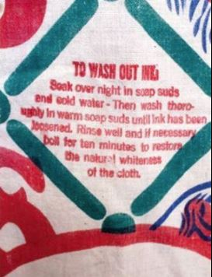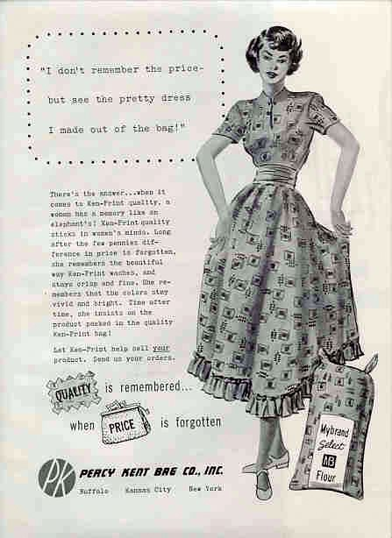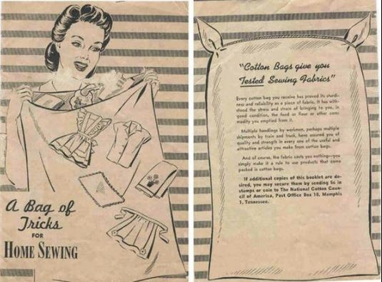

Set Design for The Tender Land
University of Arizona

Aaron Copland was inspired to write "The Tender Land" after seeing a series of photos by Walker Evans of the American South during the Dust Bowl era in the late 30's. In the book, "Let Us Now Praise Famous Men", Walker and writer James Agee showed the world how hard tenant farmer families were struggling but also, in the photos, you can see a beauty in their bonds and in the stark landscapes. According to Copland, he was especially moved by two photos - one of a mother and one of her daughter. He saw in those photos the whole story of The Tender Land, the loyalty and protectiveness in a family that survives struggling together and the pull of a new life for the young generation. The story is centered on these characters and the location and time is vital. The land and their rough home are critical to understanding the deep emotional strains of the opera.

So, for the scenery I felt that I had to start there, with the same source material that Copland did. After researching more photos, I realized that the scenery had to help the singers tell the struggles of the characters, but also their dignity and beauty. I found in the stark libretto a connection to Modern Dance, sparse and fluid , but also awkward and tense. I was excited to find out that the first director of "The Tender Land" was Jerome Robbins, a famous modern choreographer. I knew the space had to be open and encourage bigger movements. Adding to this, our Opera Director at the School of Music, Prof. Cynthia Stokes, was drawn to a painter from the era named Maynard Dixon, famous for his dramatic expressive skyscapes.

Hopefully you will see all these elements together in our production of "The Tender Land".

Sally Day
Set and Projection Designer
Opera Theater
University of Arizona

